EMPTY PARKING SLOT DETECTION

# Table of content

**Table of content** **2**

**Introduction** **3**

**Project Variables** **4**

1. Tools required 4

2. Preparing Development Environment 5

3. Get the image and video to teach and represent the camera feed 6

**Code used to identify individual parking spaces** **8**

**Project main code** **10**

**Project Outputs** **12**

Figure 5: this demonstrates how parking space is identified 12

Figure 6: This figure demonstrates the number that indicates parking space is occupied or not 13

Figure 7: This figure indicates a counter of the unoccupied versus all spaces 13

**Evaluation** **14**

**What was delivered in this project** **14**

Back end (empty car park detection) 14

What was not delivered in this project **15**

Webpage 15

Home page 16

Contact page 17

Services page 17

**Conclusion** **20**

# Introduction

Congestion in parking lots in high-density locations is commonly acknowledged as a source of frustration for drivers. Current techniques rely on either counters, which can only reveal the number of vacant spots but not their location, or on installing a variety of various types of sensors placed beneath each parking spot, which are not cost-effective and are frequently impossible to retrofit on older parking structures.

Vehicle entrance and exit counters are now used in many high-traffic parking facilities, such as those found in airports, sports stadiums, and shopping malls.

While this simple method reveals the amount of vacant parking spots on a given level, it does not offer drivers with any information about the exact position of vacant parking structures.

A system that could keep track of available parking places and send the information to drivers' smartphones or even the ticket they get as they enter the structure would improve the driver experience and alleviate congestion.

Because the sensors are fine-tuned to detect vehicles within a defined area, unambiguous street demarcations are required.

This project aims to create a system that detects vacant parking spots by utilizing current equipment available in parking garages (surveillance cameras).

The goal is to develop a more cost-effective approach that maintains similar detection accuracy.

Parking scenarios have been limited to parking buildings with consistent lighting conditions due to the difficulties of identification under varied lighting circumstances.

Furthermore, rather than relying on human interaction, the initiative aims to develop a mechanism for autonomously detecting parking lines.

Individual parking slots are identified in a controlled scenario in which each parking spot is vacant.

This is required in order to correctly identify the image's region of interest that corresponds to each parking slot.

The parking spot recognition algorithm's purpose is to: (1) recognize parking line dividers solely, and (2) record the coordinates corresponding to a parking spot using surrounding dividers.

# Project Variables

The project follows some layed out steps to get it completed.

1. Get all the necessary tools to get the project going
2. Prepare Development Environment
3. Get Still image and video to represent a camera feed

## 1. Tools required

For the project to come to light one requires the following to complete it.

* A Desktop computer or Laptop
* Development Environment also called IDE or a text editor, for this case we will be using PyCharm to develop the python code.
* Python 3.6+ compatible to Windows, Mac and Linux
* set up python path automatically while installing or manually after

Figure 1 Python installation confirmation

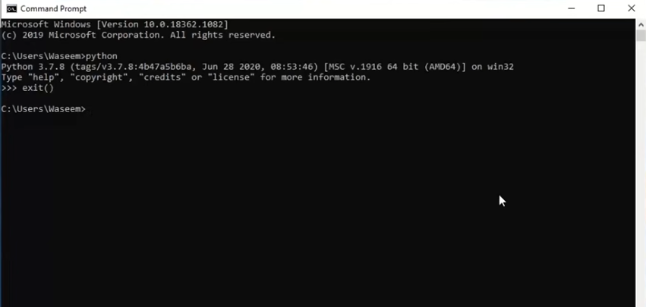

* Confirm python installation

## 2. Preparing Development Environment

For a more organized coding work a development environment is paramount. A text editor like notepad++ and sublime text goes a long way as it has a predefined structure and format for the specific languages a user prefers to code with. Making the user experience much easier compared to a normal editing tool like the default notepad application that comes preinstalled in Windows operating systems.

The steps are as follows:

* Install PyCharm
* Create a new project to begin the coding process
* Set the Virtual Environment
* Identify the variables required for the project
* Start coding

Figure 2 PyCharm

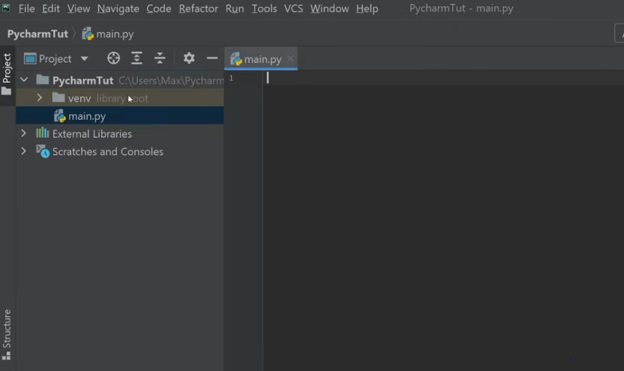

## 3. Get the image and video to teach and represent the camera feed

Figure 3 still image to be used in the project

A video file will also be provided, this video file will be a representation of the camera feed that will be at the parking lot.

From the still image we can identify the parking lot size and demarcate carefully where all the lots are positioned. After the demarcation of lot sizes, the code should be in a position to tell whether the parking lot is available or occupied.

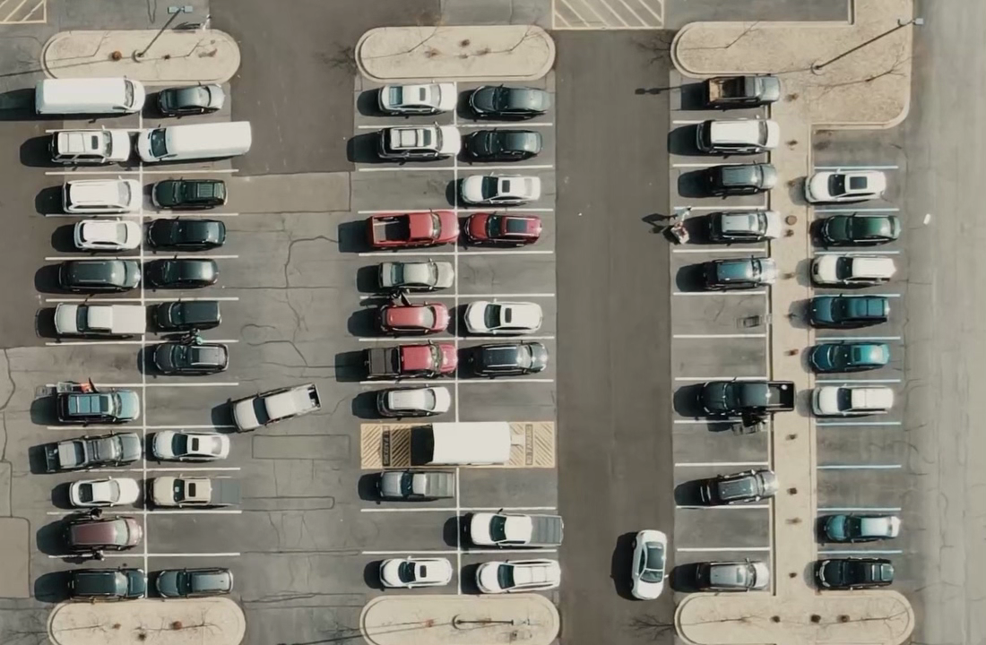

Figure 4 Still image with demarcations

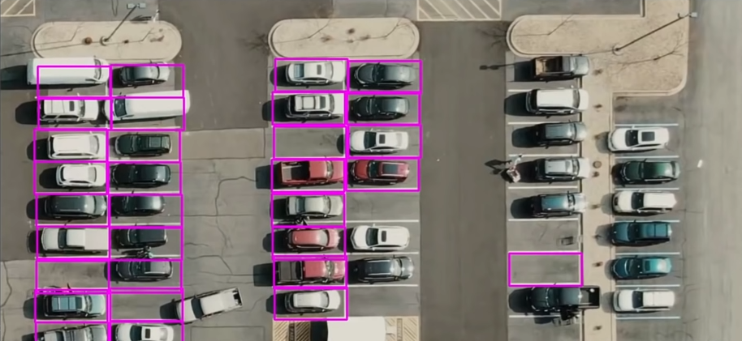

# Code used to identify individual parking spaces

import cv2

import pickle

import tkinter as tk

class mark_park():

    def __init__(self,park="new_park_plot"):

        self.park=park

        self.width, self.height = 107, 48

        try:

            with open(park, 'rb') as f:

                self.pos_list = pickle.load(f)

        except:

            self.pos_list = []

    def mouseClick(self,events, x, y, flags, params,):

        if events == cv2.EVENT_LBUTTONDOWN:

            self.pos_list.append((x, y))

        if events == cv2.EVENT_RBUTTONDOWN:

            for i, pos in enumerate(self.pos_list):

                x1, y1 = pos

                if x1 < x < x1 + self.width and y1 < y < y1 + self.height:

                    self.pos_list.pop(i)

        with open(self.park, 'wb') as f:

            pickle.dump(self.pos_list, f)

    def mark_the_park(self,image):

        while True:

            img = cv2.imread(image)

            for pos in self.pos_list:

                cv2.rectangle(img, pos, (pos[0] + self.width, pos[1] + self.height), (255, 0, 255), 2)

            cv2.imshow("Image", img)

            cv2.setMouseCallback("Image", self.mouseClick)

            k = cv2.waitKey(1) & 0xFF

            if k == 27:

                cv2.destroyAllWindows()

                break

if __name__ == "__main__":

    park=mark_park()

    park.mark_the_park("park_img.png")

This part of the code will identify the park lot spaces. The rectangular boxes of the still image. Which will then be directed to the video feed where the code will do its magic and automatically capture available and occupied spaces.

**Original image :**



**After the marking of the co-ordinates:**

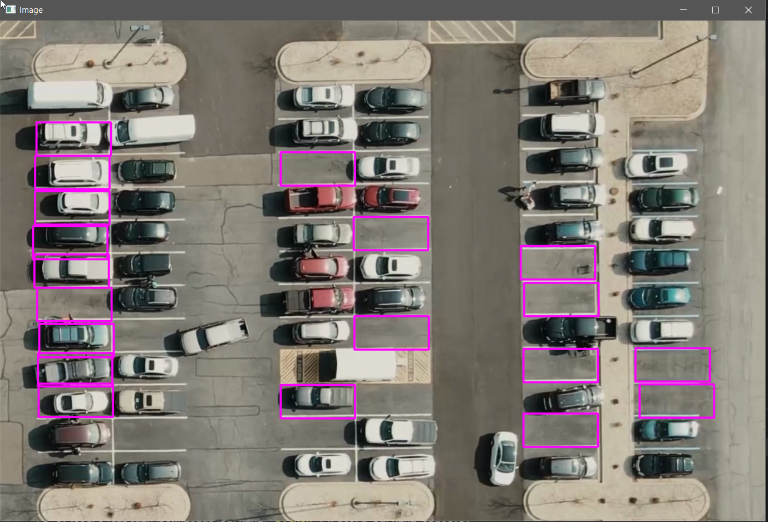

# Project main code

This represents the main part of the code where it utilizes the video acquired in the beginning of the project.

import cv2

import pickle

import cvzone

import numpy as np

from tkinter import *

from PIL import Image, ImageTk

from tkinter import filedialog

import PIL.Image, PIL.ImageTk

parking_video=""

park_pos_file=""

posList=None

width, height = 107, 48

def checkParkingSpace(imgPro,img):

    global posList

    spaceCounter = 0

    for pos in posList:

        x, y = pos

        imgCrop = imgPro[y:y + height, x:x + width]

        count = cv2.countNonZero(imgCrop)

        if count < 900:

            color = (0, 255, 0)

            thickness = 5

            spaceCounter += 1

        else:

            color = (0, 0, 255)

            thickness = 2

        cv2.rectangle(img, pos, (pos[0] + width, pos[1] + height), color, thickness)

        cvzone.putTextRect(img, str(count), (x, y + height - 3), scale=1,

                           thickness=2, offset=0, colorR=color)

    cvzone.putTextRect(img, f'Free: {spaceCounter}/{len(posList)}', (100, 50), scale=3,

                           thickness=5, offset=20, colorR=(0,200,0))

def main_task():

    global parking_video

    global park_pos_file

    global posList

    cap = cv2.VideoCapture(parking_video)

    with open(park_pos_file, 'rb') as f:

        posList = pickle.load(f)

    while True:

        if cap.get(cv2.CAP_PROP_POS_FRAMES) == cap.get(cv2.CAP_PROP_FRAME_COUNT):

            cap.set(cv2.CAP_PROP_POS_FRAMES, 0)

        success, img = cap.read()

        imgGray = cv2.cvtColor(img, cv2.COLOR_BGR2GRAY)

        imgBlur = cv2.GaussianBlur(imgGray, (3, 3), 1)

        imgThreshold = cv2.adaptiveThreshold(imgBlur, 255, cv2.ADAPTIVE_THRESH_GAUSSIAN_C,

                                                cv2.THRESH_BINARY_INV, 25, 16)

        imgMedian = cv2.medianBlur(imgThreshold, 5)

        kernel = np.ones((3, 3), np.uint8)

        imgDilate = cv2.dilate(imgMedian, kernel, iterations=1)

        checkParkingSpace(imgDilate,img)

        cv2.imshow("Image", img)

        cv2.imshow("ImageBlur", imgBlur)

        cv2.imshow("ImageThres", imgMedian)

        k = cv2.waitKey(1) & 0xFF

        if k == 27:

            cv2.destroyAllWindows()

            break

window = Tk()

window.title('Parking space monitering')

window.geometry("700x500")

bg= Image.open("parking.jpg")

def on_resize(event):

    image = bg.resize((event.width, event.height), Image.ANTIALIAS)

    l.image = ImageTk.PhotoImage(image)

    l.config(image=l.image)

def browseFiles1():

    global parking_video

    filename = filedialog.askopenfilename(initialdir = "Users/",

                                        title = "Select a File",

                                        filetypes = (("Text files",

                                                        "*.mp4*"),

                                                    ("all files",

                                                        "*.*")))

    label_file_explorer.configure(text="File Opened: "+filename)

    # inp = blur.get(1.0, "end-1c")

    parking_video=filename

    print(filename)

def browseFiles2():

    global park_pos_file

    filename = filedialog.askopenfilename(initialdir = "Users/",

                                        title = "Select a File",

                                        filetypes = (("Text files",

                                                        "*.*"),

                                                    ("all files",

                                                        "*.*")))

    label_file_explorer.configure(text="File Opened: "+filename)

    # inp = blur.get(1.0, "end-1c")

    park_pos_file=filename

    print(filename)

    main_task()

l = Label(window)

l.place(x=0, y=0, relwidth=1, relheight=1)

l.bind('<Configure>', on_resize)

label_file_explorer = Label(window,

                            text = "This is the tool built for monitering the empty parking spaces \n-------------------------------\n Steps to use the application \n-------------------------------\n 1)If you are using a new parking lot then record the co-ordinates of the parking spots (use Right click of the mouse). \n 2) After recording the co-ordinates choose the video file that is to be monitired \n 3) choose the file in which co-ordinates are being saved \n \n ESC - to close the window",

                            width = 105, height = 9,

                            fg = "blue")

button_explore1 = Button(window,text = "Step-1) Select the video file to moniter.", width=55, height=2, command = browseFiles1)

button_explore2 = Button(window,text = "Step-2) Select saved position file and start monitering.", width=55, height=2, command = browseFiles2)

button_exit = Button(window,

                    text = "Exit", width=15, height=2, command = exit)

label_file_explorer.grid(column = 0, row = 1,pady=10)

button_explore1.grid(column = 0, row = 3,sticky="w",pady=10,padx=180)

button_explore2.grid(column = 0, row = 4,sticky="w",pady=10,padx=180)

button_exit.grid(column = 0,row = 7,sticky="w",pady=10,padx=180)

window.mainloop()

It Consist of a simple GUI:

**Figure 6:**

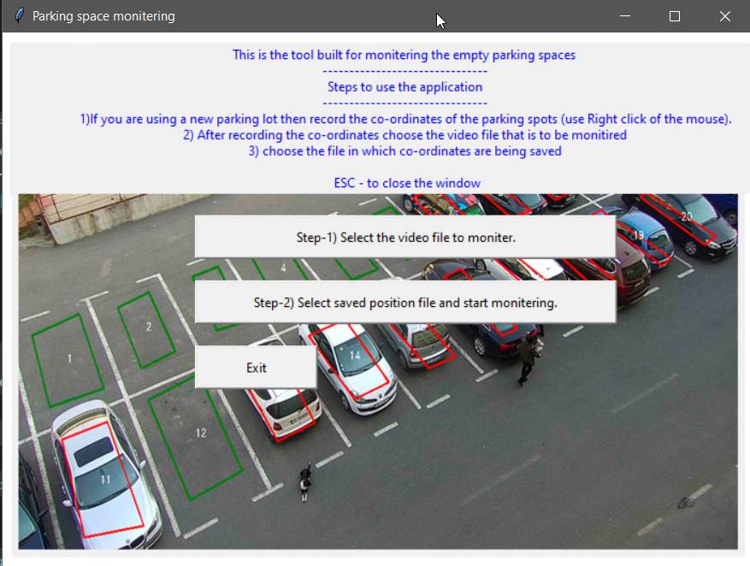

And the main functionality of the code is to count the black and white pixel difference.

The Demonstration of the theory:

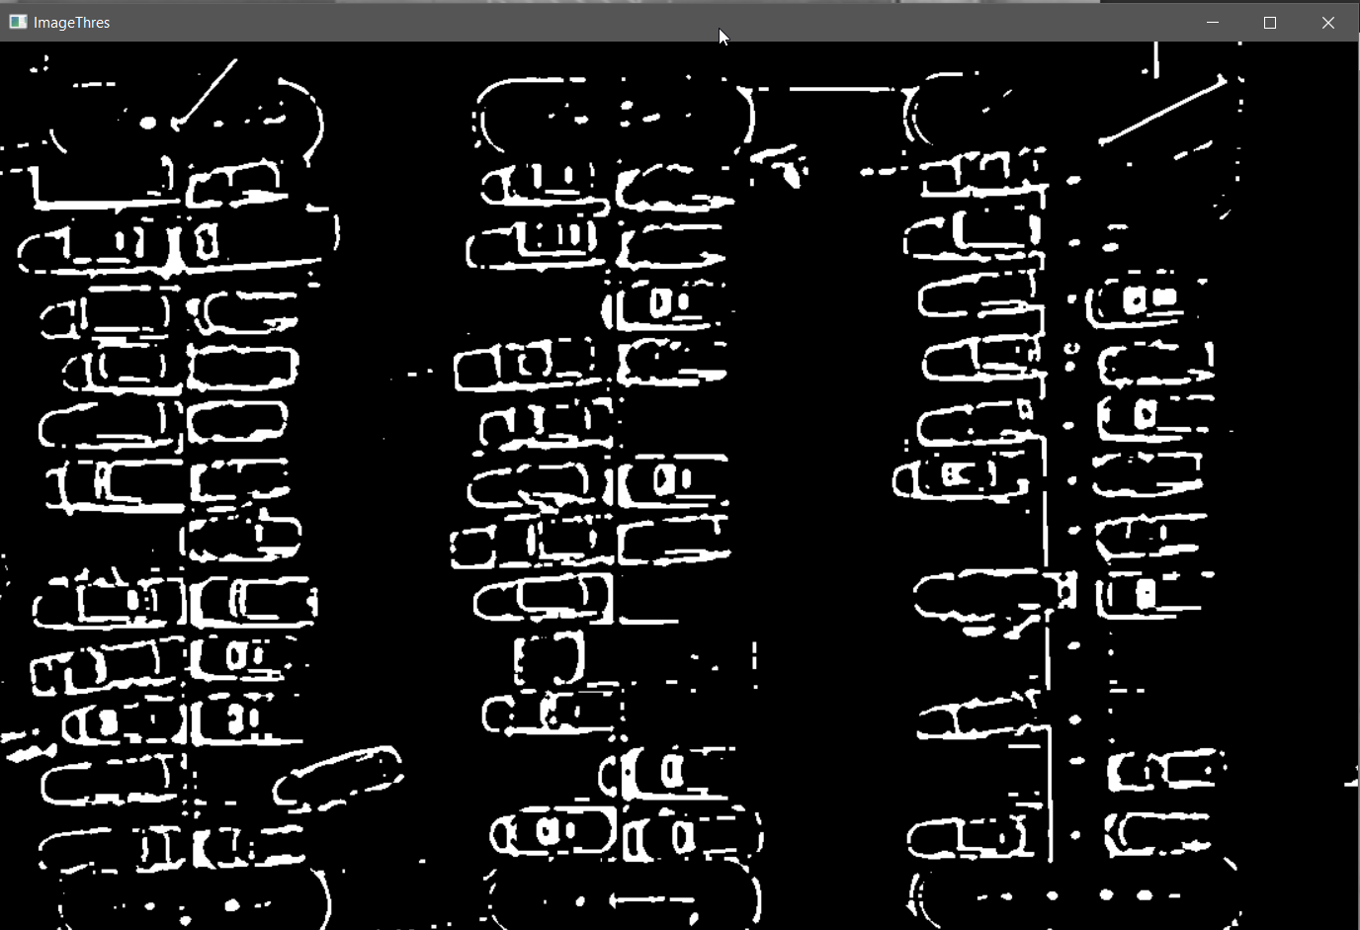

# Project Outputs

### Figure 5: this demonstrates how parking space is identified

The rectangles with red borders indicates occupied space

The rectangles with Green indicates available space

### Figure 6: This figure demonstrates the number that indicates parking space is occupied or not

### Figure 7: This figure indicates a counter of the unoccupied versus all spaces

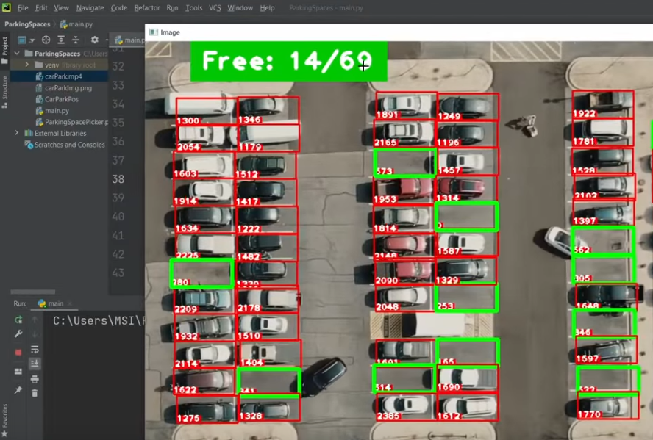

Figure 7 demonstrates the entire parking lot spaces and the available parking lots. That is the parking lots that are not occupied.

# Evaluation

The project included two main parts

1. Back end - empty car park detection
2. Webpage

# What was delivered in this project

## Back end (empty car park detection)

The back end is complete as it is the part that communicates to the field sensors which in our case is the cameras. This module gets the entire car park picture and demarcates it with rectangular boxes indicating that it's a parking space. Red colored borders indicate that the space is occupied while Green borders indicate available space.

The figure below describes the scenario above

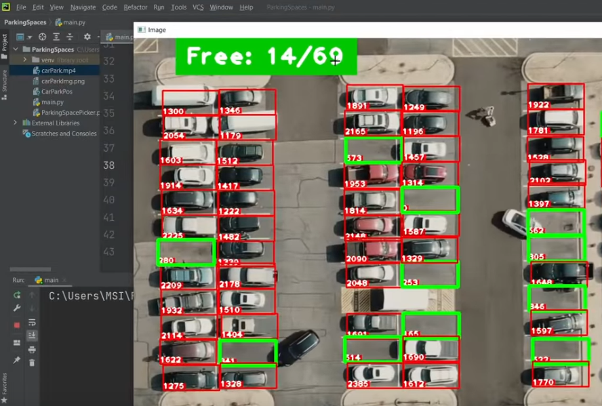

# What was not delivered in this project

## Webpage

As the word suggests this part of the project was to be a webpage or that a website that would hold pages containing useful information that the user would interact with to the services they were looking for.

This is the second module that was supposed to be a web structured design where a user would get the posted data collected by module 1.

A user would access the information via a web page that would be publicly available for the user to access. All the user needed was active internet access and they would access the system.

This system would post the free or rather available parking lots in the web page where the user would later book or pay for the spaces and this would make their life much easier and convenient.

The website was to meet it purpose by incorporating several pages, this include

1. Home page

This page should be the landing page when a user accesses the website

1. About us Page

This would give the user information about the company in our case the project

1. Contact us page

This should demonstrate to the user how to get us incase they need assistance from the us

1. Services page

This page would demonstrate to the user the kind of product they have and the services we offer

### Home page



### Contact page

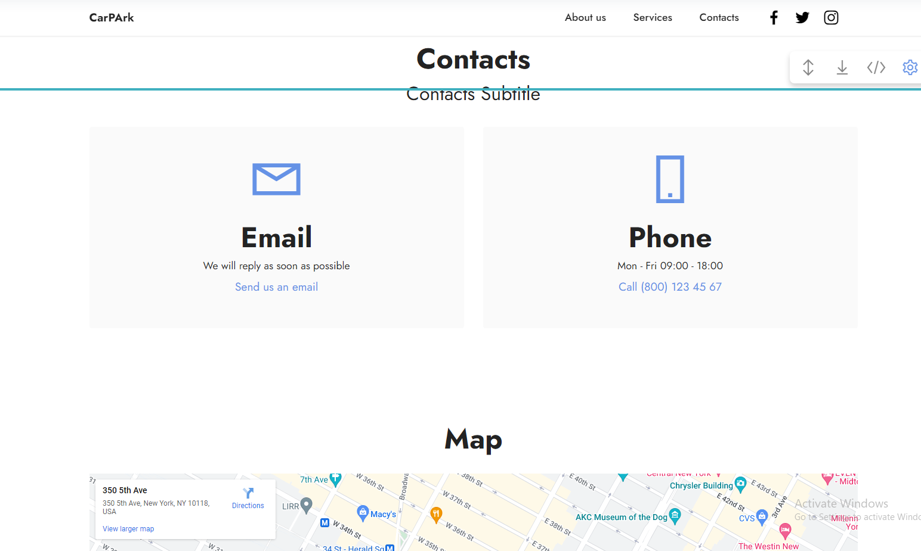

### Services page

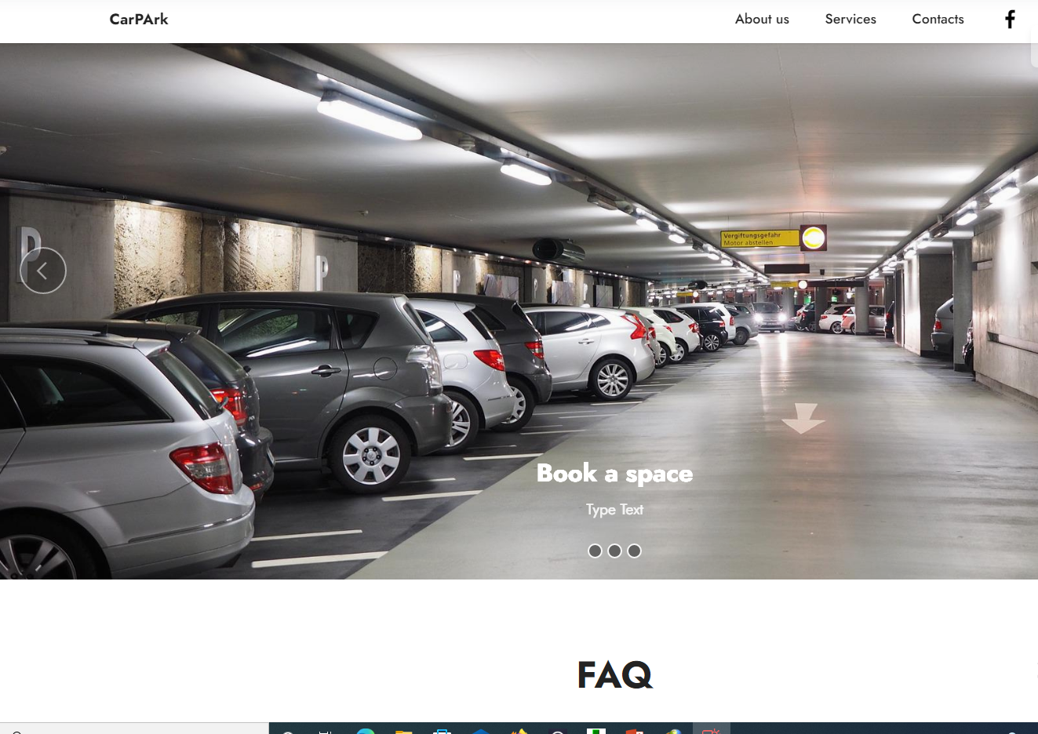

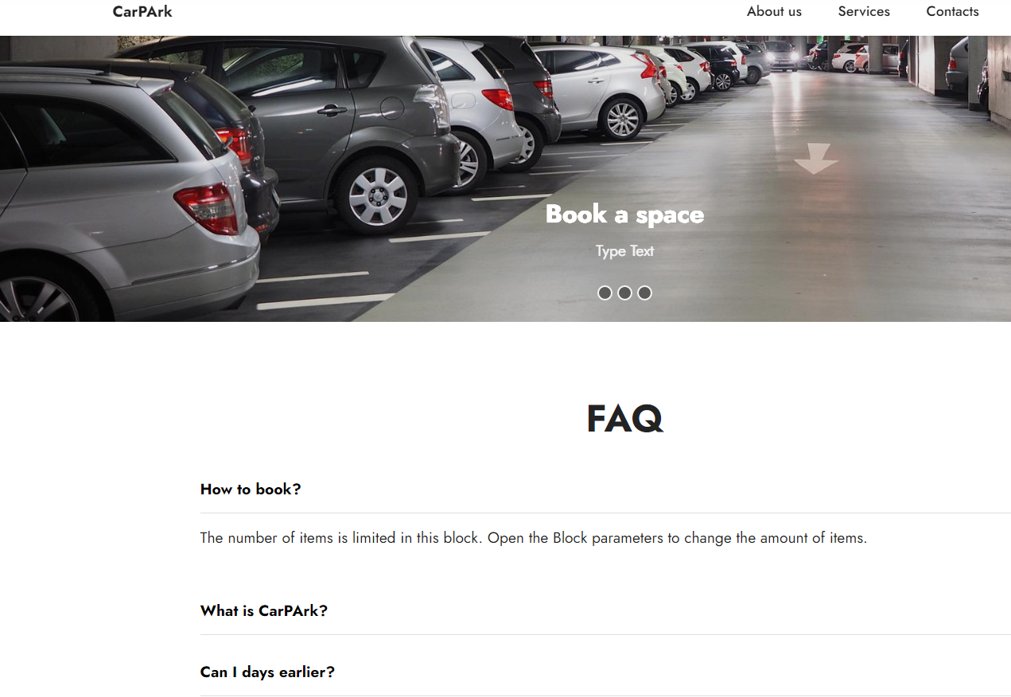

Indicates some of the services to be offered

1. Book a space
2. Check available space
3. Frequently asked questions answered

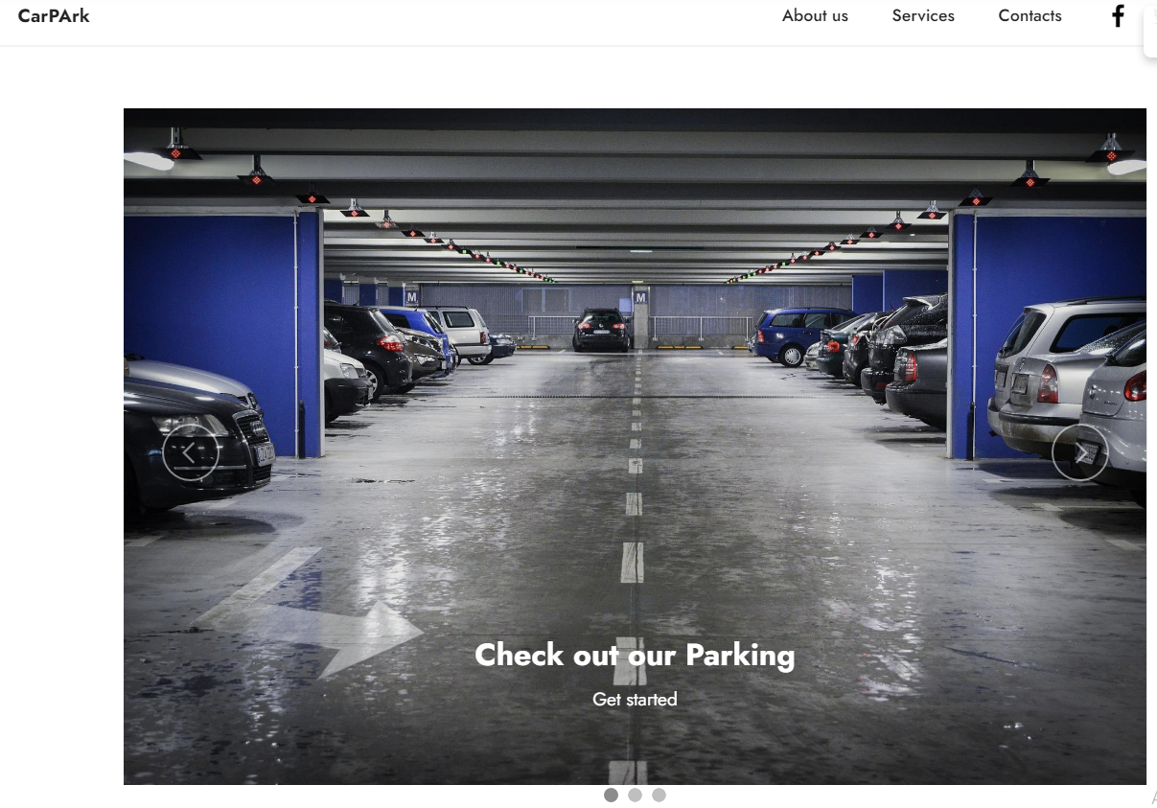

The second module was not done in this project but the first module is complete. This module as discussed above interacts with the field devices in our case which is the camera. Locates empty parking lots and stores that information. This information would have later been retrieved by the second module and pushed to the user requesting.

What has been achieved

1. Detecting an empty parking lot

This has been done by the code posted above.

# Conclusion

The sole esense for this project, Empty Parking Lot Detector was to make use of available technology aid in the manually relied method of identifying empty parking lots.

The mission of this project has been obtained as the project can access the camera feed and detect empty park lots. This concludes the project with confidence.